Framework Enhancements

Project structure
Relevant folders are predefined for better code clarity
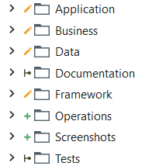
- Application for all UI interactions
  - InitAll.xaml, CloseAll.xaml and KillAll.xaml (applications) belong to this folder
  - Each application in its dedicated subfolder (e.g.Notepad)
- Business for process specific workflows/logic
  - Process.xaml belongs to this folder
  - SetupContext.xaml for one time generic initial setup (besides applications): download files, create folders, get timestamps, etc.
  - CleanUp.xaml for deleting temporary process file handles mostly
- Operation for data handling (file management, text and table manipulation)
- Service for external systems integration (databases, API)

New Features
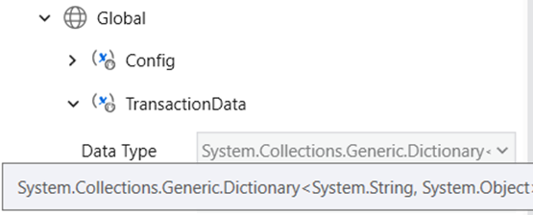
- Having Config and TransactionData defined as global variables makes them available throughout the project without passing them as arguments in all workflows
- TransactionData type is set to Dictionary<String, Object> in accordance to TransactionItem.SpecificContent which holds relevant information for the transaction. This data type offers flexibility for appending fields/information of any other type throughout the process
- GetTransactionDataFromTable.xaml is a readily available alternative to GetTransactionData.xaml for working with input from Excel and CSV files, built on compatibility with TransactionData Dictionary data type
- SaveProgress.xaml automatically generates the execution report, based on predefined template (Data/Report.xlsx)
- Email templates are provided in Config/Settings sheet and appropriate notifications are sent for signaling exceptions (NotifyFailure.xaml) and sharing execution report (SendReport.xaml)

Config Updates
- Moved all framework log messages to Config/Constants for easy language customizations
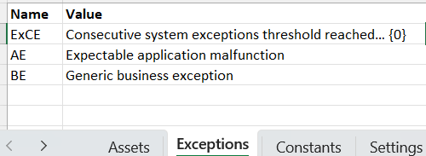
- All known exceptions (BE & SE) are listed on the Config/Exceptions sheet. Not only does this make it easier to manage error messages, but hard coding exception messages when raising an exception can now be avoided. Raising the exception code instead (e.g. BE1) is then replaced with the corresponding message in TranslateException.xaml that is invoked from SetTransactionStatus. Details can be passed into the message (e.g. TransactionID) via Exception.Data property

- Added support for Config extension, a clone/version of Config.xlsx available for editing to the business team (in a fixed predefined location) whose contents take precedence over the defaults in the project configuration. This is useful in case of an attended automation running without Orchestrator. In preparation for this feature, InitAllSettings.xaml was renamed to LoadSettings.xaml (as it now gets called twice)

Debug and Testing Utilities
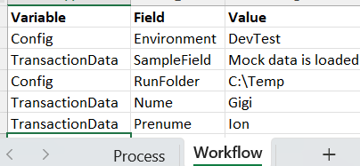
- MockData is a feature that allows Config and TransactionData test values to be loaded from an Excel file. This is helpful for testing workflows in the middle of the process that require some transaction context. To use this feature, simply add a sheet in Tests/MockData.xlsx with the workflow name (or test case name) where Config and TransactionData names and values are defined. Then at the beginning of the workflow to be tested, add an invocation to MockData.xaml, passing in the Sheet name. MockData invocation is benign at runtime.
- ShowVariables.xaml is a complementary workflow that dumps global variables (Config and TransactionData) content into an Excel file, optionally saving it on disk with a timestamp as well
- CheckAssistPoint.xaml pops a message box waiting for user confirmation at key points in the process. This is particularly useful when going live with processes that perform irreversible actions (e.g. payments) to allow business user to verify the robot’s input to the process. Feature may be turned on and off via an argument to Main.xaml that can be set from Assistant or from Orchestrator. In case of a basic attended bot, more logic can be defined on Yes/No user choices

